New Closed User Group | January 1  2017
The following user guide introduces the new Health and Safety Closed User Group. It discusses new features and guides users’ through the site, highlighting how to setup events, delegates and how to view historical entries. |  | Health and Safety

Contents
New Closed User Group 3
Menus 4
Dashboard 5
Events 6
Add event 6
Edit event 9
Adding delegates to events 10
Clicking ‘create new delegate’ 12
Approvals 15
Delegates 18
Edit delegate 21
Delete delegate 22
Add new delegate 24
Link event to delegate 24
Archive event 26
View archived events 27
Resources 28
News .30
Contact 31
Conclusion 32

New Closed User Group
The new Closed User Group is designed to give RDTHSCs more control over the creation of delegates and events. The site will also allow RDTHSCs to view details of previously submitted training carried out by them. The site is designed to work on a mobile and tablet.
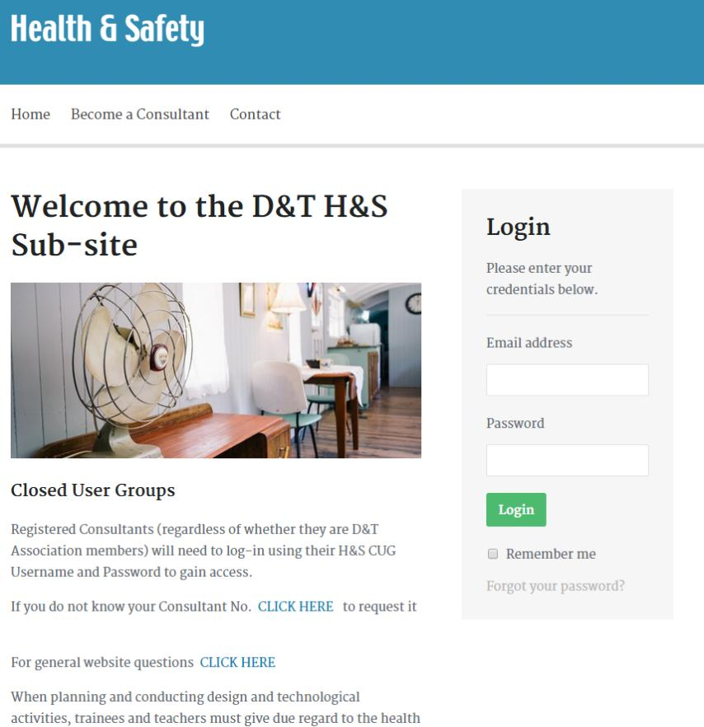

Menus
Similar to the previous website, users’ will see a different menu when they’re logged in from one that is viewed by everybody.

Logged out screen menu


Logged in screen menu

Dashboard
The Dashboard is designed to get the RDTHSC started quickly. A user will be able to quickly setup Events and Delegates by clicking the appropriate link.
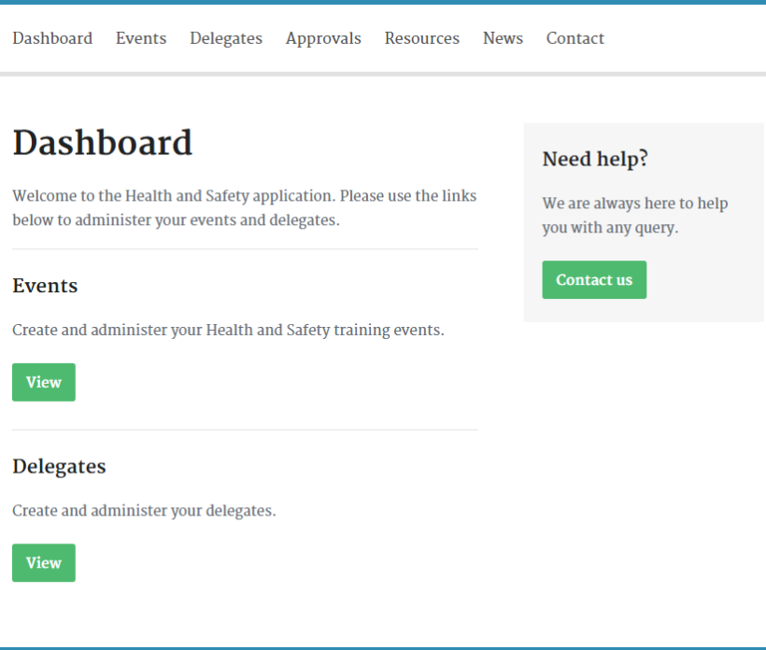
The system is designed to allow RDTHSCs to create events and delegates before or after an event has taken place. With events and delegates being created separately, an RDTHSC can then link one to the other once training is completed. An event can be linked to a delegate or vice versa.

Events
When you first browse to the Event page, it will be empty, ready to be populated with Events.
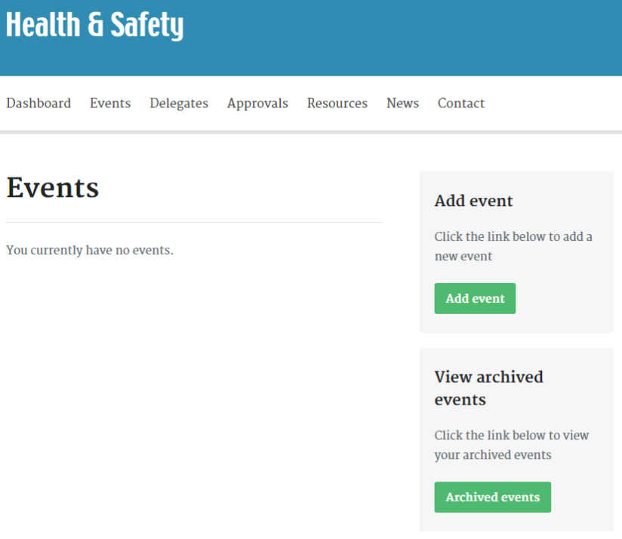

Add event
To add an event press the ‘Add event’ button and provide the required details. Because the system is designed to give RDTHSCs a history of the events they have undertaken, it serves to fill in all the fields.
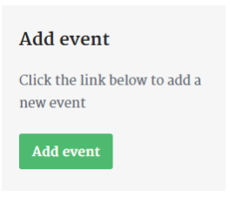
Once the form has been completed press the ‘Add event’ button which appears at the bottom of the form.
NB: The comments section can be used for personal notes.

You will then be taken to an overview screen which allows you to see the newly created event. 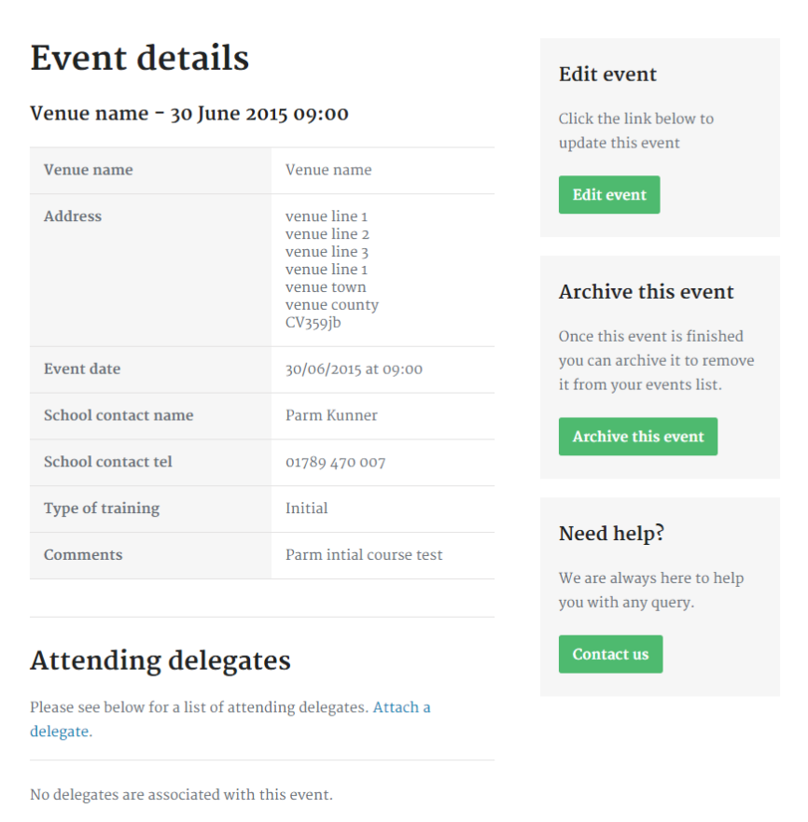
At this point you will be presented with a number of options. You can:
- edit the event
- add delegates (which have already been added via the delegate section)
- archive the event

Edit event
If you have made a mistake, it is advisable to edit the event at this point. Selecting this option will take you to an edit screen with the details pre-populated.
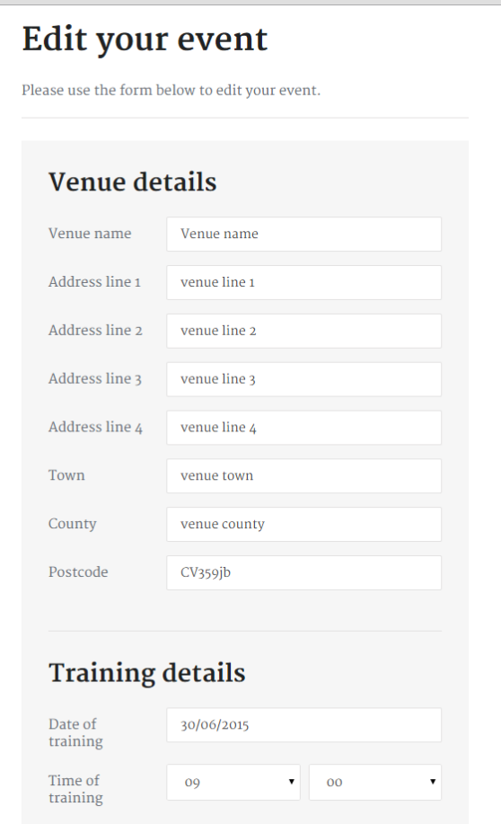
Review the information and press ‘Save changes’ when you are satisfied the details are now okay.
The save icon is found at the bottom of the edit page

Once you are happy with the event, it is presented as a list on the event page. Click ‘Events’ in the menu to be taken to the ‘Events’ page.
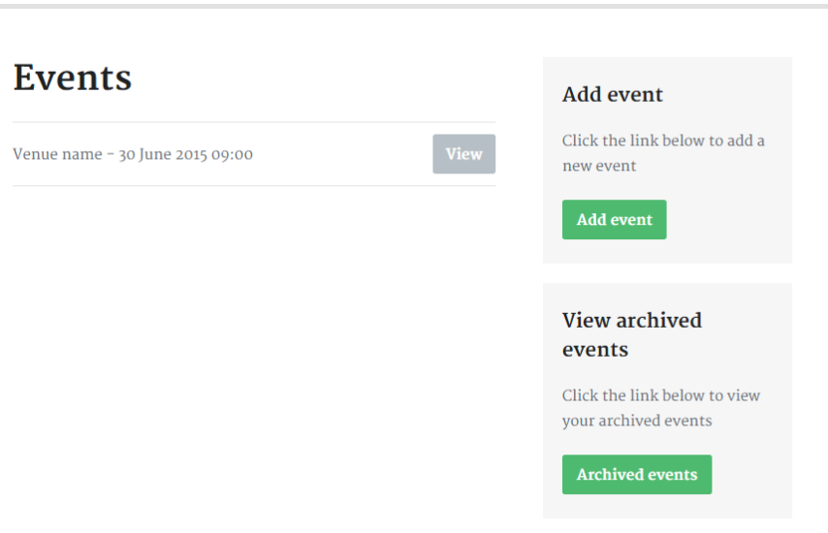
On this page, you will be presented with two additional options. They are:
- add event
  - This option will take allow you to add more events as bookings are confirmed, in essence, start the process again.
- view archived events
  - This is simply a way to view archived event. This option is discussed later in the user guide.

Adding delegates to events
The system allows you to attach delegates to events and events to delegate. So, even at this point, you can create a delegate.
Pressing ‘Attach a delegate’ will open the ‘Attach delegate’ area.
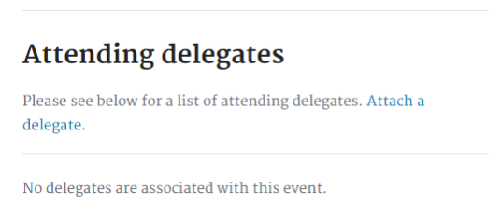

Here, you could attach a delegate if you had already created one, or you could create a new delegate record.
The image below shows the ‘Attach delegate’ box.  Clicking ‘create new delegate’ allows you to add new delegates. | If delegates had been created before an event, then clicking the drop down list will present a list of delegates currently in the system.  The list below is from the testing carried out.
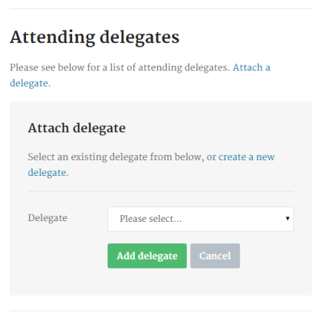 | 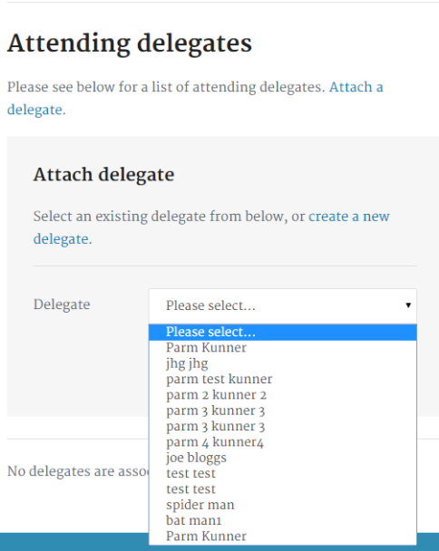

Clicking ‘create new delegate’
By selecting this option the user is taken to the ‘Add new delegate’ screen. Here, RDTHSC must enter details for the delegate attending the event.
Because the option to add a delegate from the event screen was selected, the system will link the new delegate against the event.
Once a delegate has been created, only at this stage the system will allow the RDTHSC to pick the accreditations the delegate has been trained in.
Select ‘Add delegate’ once the information has been supplied. Attach to the event once the training has been completed.
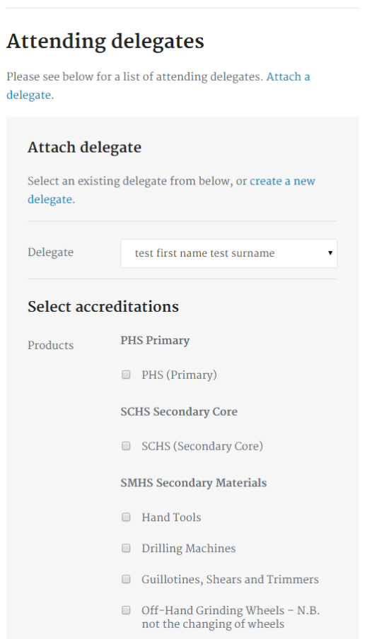 | 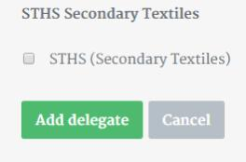

The delegate is now added below the event details.
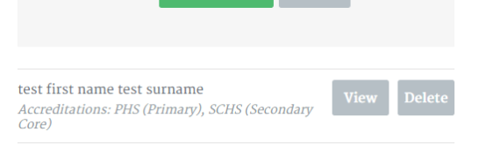
Once added, you can view the delegate’s details or delete the record. You can repeat process to add more delegates, or add delegates via the ‘Delegates’ menu.
If a delegate requires additional training at this stage, then the process to add more accreditations is quick and straight forward. You will need to delete the current delegate off the event and re-attach them selecting all the training covered.

Approvals
The approvals section is new to CUG and its purpose it to collate past events (and delegates linked to events) to one area so an RDTHSC can then send for approval.
Once an event passes the current date, it will move to the Approvals area.
A delegates name is presented to the RDTHSC along with all the events the delegate has attended.
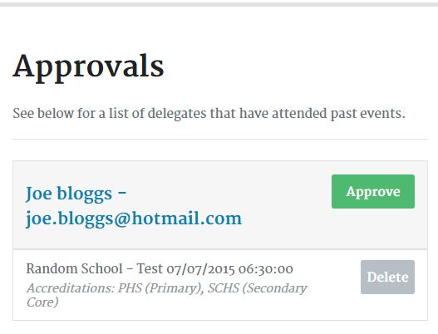
Clicking the delegates name will take the RDTHSC to the ‘Delegate details’ screen.
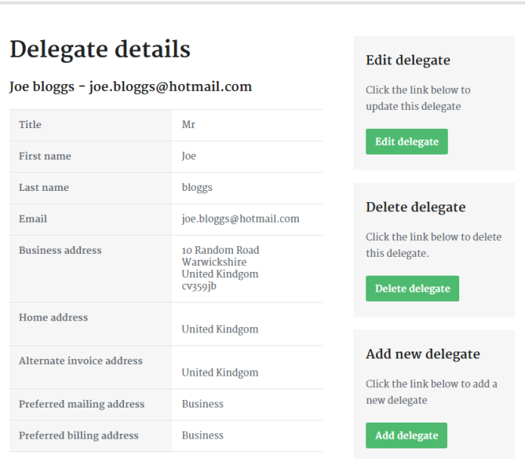 | If the details are incorrect, they can be amended by clicking ‘Edit delegate’.  Once the details have been amended, save the record.

If the entry is okay, pressing ‘Approve’ will submit the record to Admin. The record is removed from the Approvals area and an alert message is presented to the screen.
However, before the record is accepted, Admin is able to view the record and, if there is an error or something missing, will reject the entry. A rejected record is sent back to the Approvals section. The delegate name will now have a (1) next to it so the RDTHSC can see it has been rejected.
NOTE: A supporting email may be sent to the RDTHSC explaining why the record has been rejected.
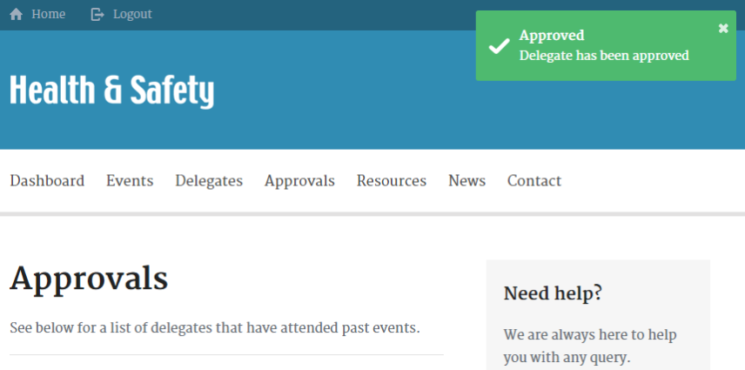

Delegates
The system allows the setup of delegates before or after an event. This is a great benefit of the system and should spread the workload for the RDTHSC.
The system is similar to the add event section described above.
When you first browse to the area it will be empty, ready to be populated.
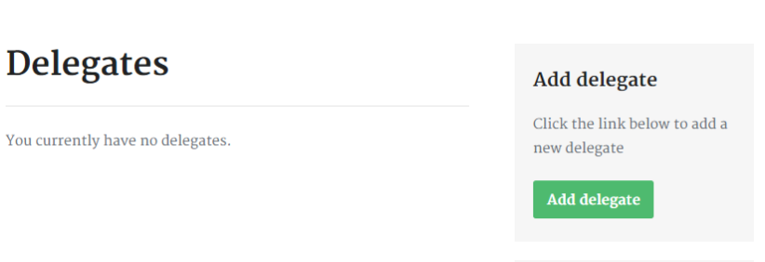
Select ‘Add delegate’ to add a new delegate.
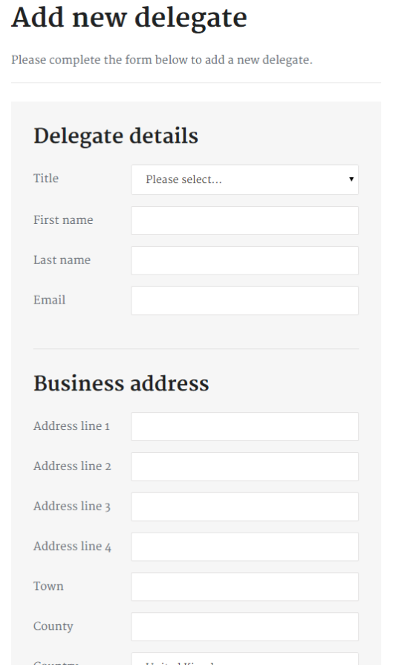 | So that RDTHSCs can get the most from the system, and to be able to remember delegates when viewed in an RDTHSC archive in later years, it is recommended to complete as many fields as possible on this screen.  Incorrect spellings or inappropriate spaces in postcodes may hinder future search results.

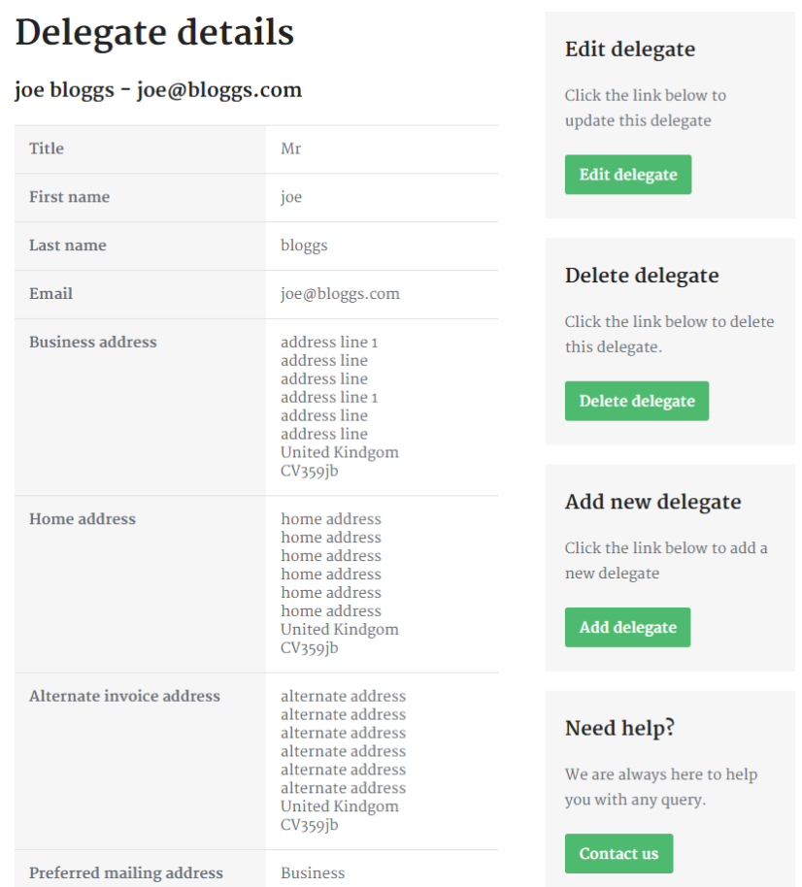
A few options are available once a delegate has been added to the system. You can:
- edit the delegate
- delete a delegate
- add a new delegate

Edit delegate
Editing a delegate’s details simply allows a user to adjust delegate details – the details are pre-populated. Here an RDTHSC can amend a record if they see an error. Once happy with the information, press ‘Save changes’ to save the record.
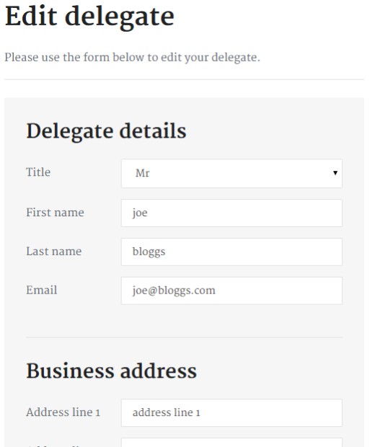 | 

Once the record has been saved the user will be taken back the delegate details overview screen, where the same options are available.

Delete delegate
This feature allows for the deletion of delegates. Clicking the button will bring up an alert box which confirms if the delete request is valid.
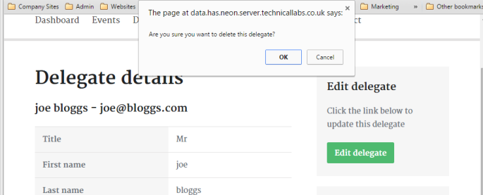
Selecting ‘OK’ will delete the delegate and take the user back to the list of delegates – see below. A green alert box confirms the action has been completed.
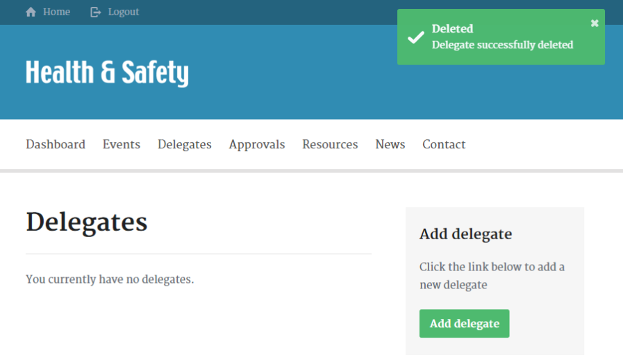
Add new delegate
To allow delegates to be created quickly, the system allows users’ to add new delegates shortly after the completion of the current entry.
Clicking the ‘Add new delegate’ starts the process again.   | 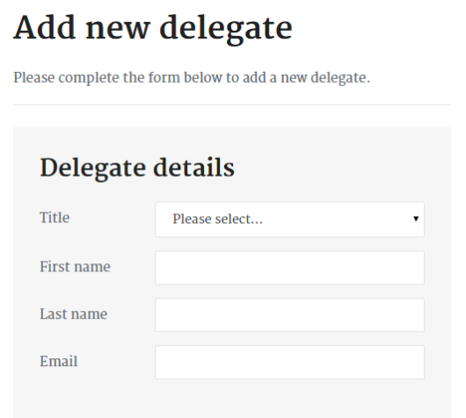

Link event to delegate
Similar to the option of adding delegates to events, linking events to delegates is also possible. This makes either route an option when connecting one to the other.
Once a delegate has been setup, an option will appear under the delegate’s details to link an event.
Users’ can select ‘Attach an event’ to select an event. If no events are in the system, a user can setup an event by selecting ‘Create a new event’.

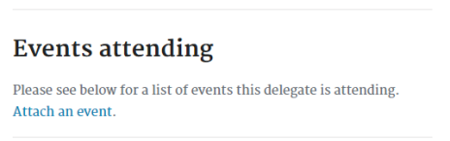 | 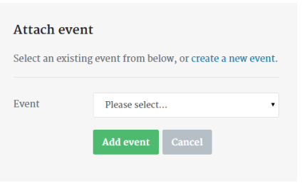

If an event is already in the system, it will appear in the drop-down list.
Once an event has been selected from the drop-down list, press ‘Add event’ to link the event to the delegate.

Archive event
Once an event has passed and all the delegate details have been sent for approval, the event can be archived. (It is strongly recommended that archiving takes place either after the invoice has been received or 6-8 weeks after the event in case amendments are required). As mentioned earlier, the new system allows RDTHSCs to view a history of their previously delivered training sessions.
Selecting ‘Archive this event’ will move the event to an archive area. Before an event is moved to archive, the system will ask if you are sure you want to archive a particular entry.
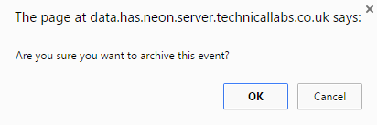
WARNING: once an event has been archived it cannot be undone. If an RDTHSC has accidentally archived an event, before submitting to admin, but missed delegates from that event, the event and delegate(s) will need to be re-added.

View archived events
To view archived events and delegates, click the ‘Archived events’. Selecting this option will take the user to a list of previous events.

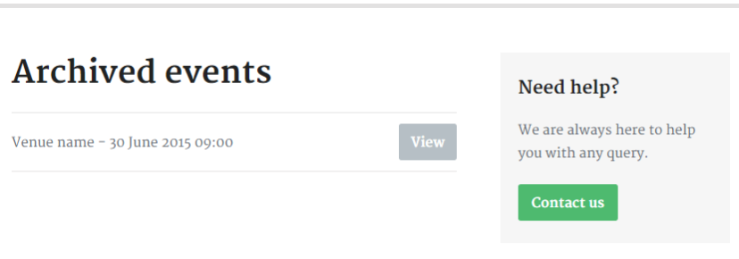

Clicking ‘View’ against an event will present the event’s information and any delegates linked to the event with their training details.

Resources
The resource area of the site will allow users’ to download training materials. It has been structured into the appropriate separate areas for each subject. The first page will show the common resources required for every training session.
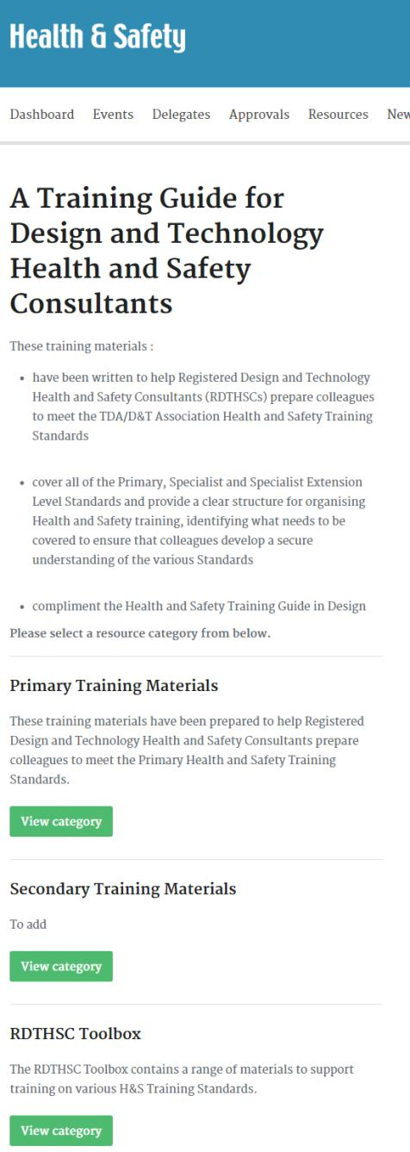 | Resource section on new Closed User Group  The resources are categories by Primary, Secondary and RDTHSC Toolbox. Should there be additional resources, they will be located on this page.  Clicking ‘View category’ will open another page where resources linked to the category can be found – the example below is taken from the Primary category.  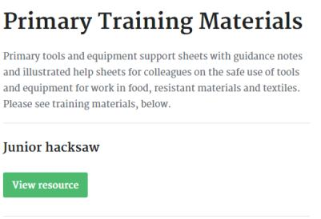  View the resource to download the file.  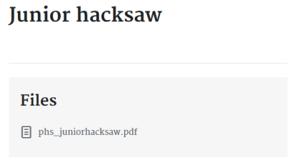

News
The news section of the site is simply an area designed to serve the latest Health and Safety news. Here, you will find updates that were originally relayed by email over the past few years but are still current or useful. on the ‘H&S Updates & News’ page on the previous Closed User Group.

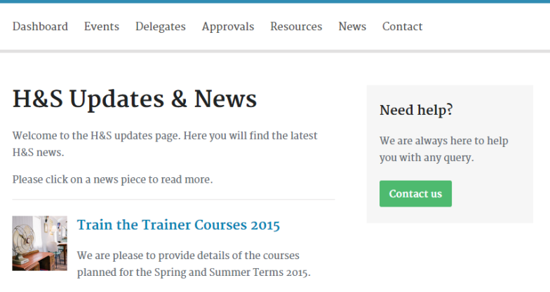
News page on New Closed User Group
Train the Trainer Courses 2015 has been taken from above as an example

The updates / news items will be organised based on date, with the most recent article at the top of the page.

Contact
New to the Closed User Group, the contact form will allow users’ to contact the H&S admin team. Please complete the fields and press the ‘Send enquiry’ button to get in touch.
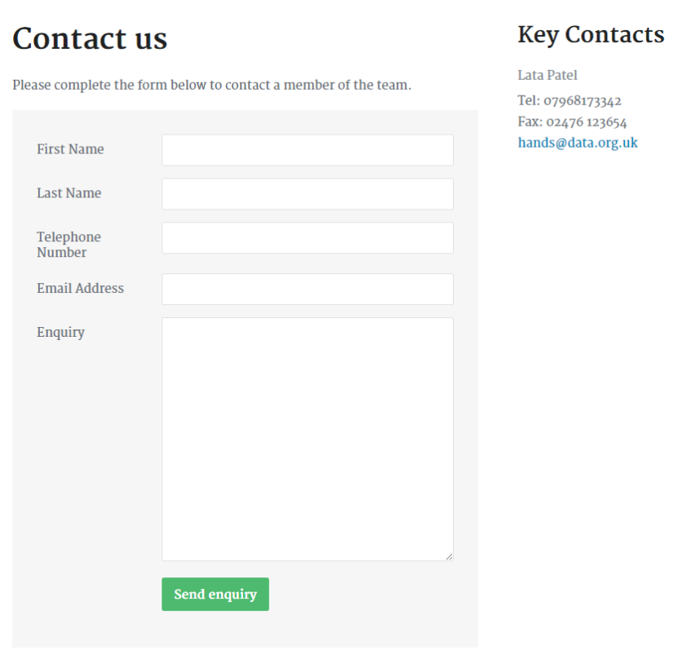

Conclusion
This guide has outlined the new Closed User Group and steered you through structure of the site. If further assistance is needed, please contact the Association by using the contact form on the website.

Guidance Notes
Create event as soon as it is booked into your diary
Once training session has been completed, add all the delegate details
Go to ‘Events’ and attach delegates adding the training details. If the Event has a past date, the names will appear in the approvals section ready for submission to D&TA Admin.
If a delegate is booked for more training, it would be wise to attach delegate to Event after all training is complete. Remember to change the event date to the last training date before attaching the delegate as this is what will appear on the certificate.
If a delegate record has been submitted and some training has been omitted, please contact Admin to reject the record so the RDTHSC can make the amendments and submit for approval again. Amendments to training cannot be made from the admin side. Equally, if Admin has already processed the record, amendments may not be possible.
Do not submit a duplicate record as an invoice will be raised against the entry.
If an accreditation has been omitted in error on a delegate record and providing the record has not yet been sent via Approvals, in order to edit the record:
- Open the event and delete the person from the bottom
- Attach the delegate again and re tick ALL the accreditations again before saving
- Record is now ready to be submitted via Approvals.
N.B
Once a delegate record has been created and attached to an event, the delegate record cannot be used again regardless of it appearing in the drop down list for an event. Therefore, if the same person undergoes more training a year later, a new delegate record must be created before attaching to the event. If this is not done, the record will not appear in the Approvals section.

